

**TIME**

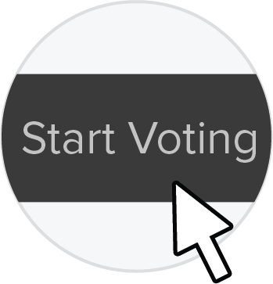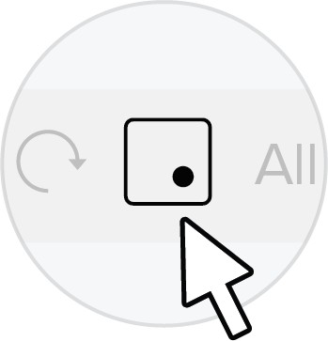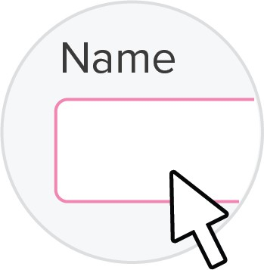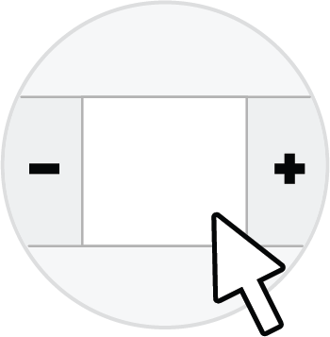

Flag the most compelling areas of focus using Visualize the Vote

*Quicklyreachconsensusaboutthekeymomentsinthe experiencethatshouldbetheteam’sfocus.*20 minutes

Click the **Voting Session** button in the menu above

Click

**Start Voting**

**Name the voting session**

(e.g. "Most impactful statements")

Change the **number of votes to 3**

**3**



Prepare 'needs statements' by framing 'moments of truth'

*Usingthemomentsoftruth,frametheissuesandopportunities intheformofthefollowingshortphrase:[Persona]needsaway to sothat . Identifythemesstemmingfromsimilar ideas.*40 minutes

A Hospital Management

reduce the issue faced by the

the patient's can feel less tensed

The Patient

tell their conditions clearly to the Data Scientist

the patinet get the correct

Persona

do something that addresses

The persona

Persona

do something that addresses

The persona

Persona

do something that addresses

The persona

needs a way to so that .

patients

needs a way to so that .

and the Dcotors

treatment

needs a way to so that .

their need

benefits

needs a way to so that .

their need

benefits

benefits

needs a way to so that .

their need

Moment of Truth

Moment of Truth

Moment of Truth

Moment of Truth

Moment of Truth

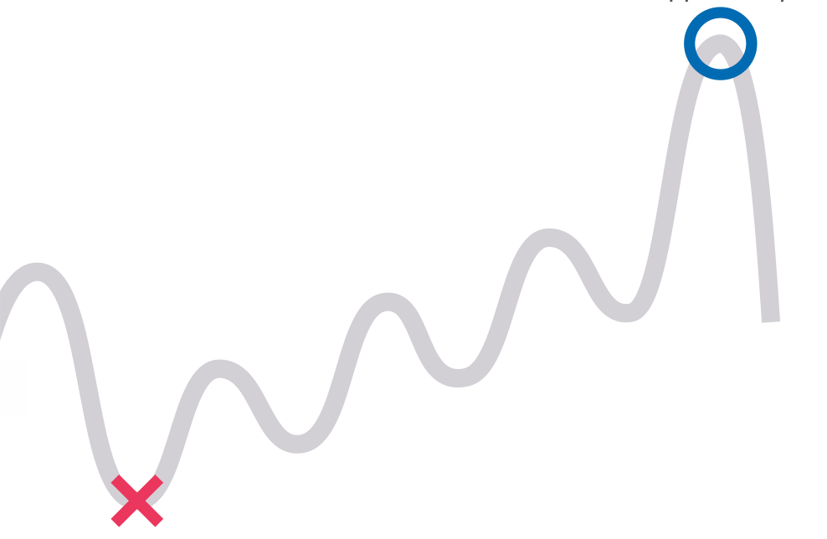

Identify Moments of Truth

by evaluating issues and opportunities

*Evaluatethejourneymaptofindissuesoropportunitiesinthe customerandemployeeexperience*45 minutes

Phase:

Phase:

Phase:

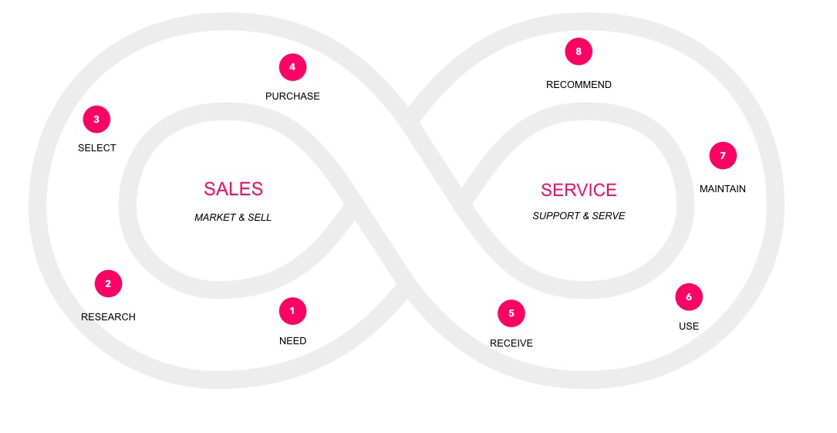

**TIP:**

**Use MURAL's timer feature to stay on track!**

Visualize the **Customer** and **Employee** interactions and touchpoints using Journey Mapping

*Workingasagroup,maptheexperienceofthepeopleyourcompanyservesleveragingthecustomerlifecycle. Includecustomerbehaviors,touchpoints,andattitudes/emotions.Next,maptheexperienceoftheemployees engagedinfacilitatinganddeliveringthecustomerexperience.Includeinternalprocesses,teams/groups,systems/ toolsandpainpoints.* 4 hours

**PHASE**

What are the high-level phases across the customer journey?

**CUSTOMER BEHAVIORS**

**CUSTOMER BEHAVIORS**

**CUSTOMER BEHAVIORS**

**CUSTOMER BEHAVIORS**

**TOUCHPOINTS**

**TOUCHPOINTS**

**TOUCHPOINTS**

**TOUCHPOINTS**

Touchpoint

Touchpoint

Touchpoint

**ATTITUDES + EMOTIONS**

**ATTITUDES + EMOTIONS**

**ATTITUDES + EMOTIONS**

**ATTITUDES + EMOTIONS**

**INTERNAL PROCESSES**

**INTERNAL PROCESSES**

**INTERNAL PROCESSES**

**INTERNAL PROCESSES**

**TEAMS + GROUPS**

**TEAMS + GROUPS**

**TEAMS + GROUPS**

**TEAMS + GROUPS**

**SYSTEMS + TOOLS**

**SYSTEMS + TOOLS**

**SYSTEMS + TOOLS**

**SYSTEMS + TOOLS**

**ATTITUDES + EMOTIONS**

**ATTITUDES + EMOTIONS**

**ATTITUDES + EMOTIONS**

**ATTITUDES + EMOTIONS**

**ATTITUDES + EMOTIONS**

What attitude or emotion does the journey evoke?

**SYSTEMS**

**+ TOOLS**

What systems and tools are used to deliver the experience?

**TEAMS + GROUPS**

What teams and groups are engaged in delivering the experience?

**INTERNAL PROCESS**

What are the steps taken internally to support the customer behavior?

**ATTITUDES + EMOTIONS**

What attitude or emotion does the journey evoke?

**TOUCHPOINTS**

What channels does the customer use to reach you?

**CUSTOMER BEHAVIORS**

What are the actions taken by the customer?

***SELECT***

VISUALIZATION,ANALYSATION,EXPLORATION

***TOVIEWDASHBOARDANDGETINFORMATION***

Employee and customer can have mutual interaction through the dashboard.

Help section is present in the dashboard which guides the whole journey for the customer.

If there are any issues ,customers can send a query regarding their problem to the employee.

Exploration Tools

Visualization Tools

Cognos Analytics

A reception team in the hospital to overlook the issues faced by the patients

A Hospital Management allocate the team(nurses and helpers) to help the patients

A group Data Scientist's form a team to accurately predict the length of stay(LOS) for patient's

Intraction between the patients and the Data Scientist can manage the things in optimal mannar

Exploration helps to Pictorial representation for patients understanding

Visualization helps the patients to know about their health conditions clearly

Customers has the access to change the values at any time.

Keeps track of the data so that the medical history of customers are well-defined

Impressive UX design are made to design the outlier.

The patient's reach the hospital nurses and helpers, while facing any issues

After get thier ranges from the Data Scientist, they get a help from hospotal help desk

At first the customer reach the Data Scientist of health man to know their length of stay

Collect information from dashboard

Analyse the data

Update the dashboard

To view the dashboard

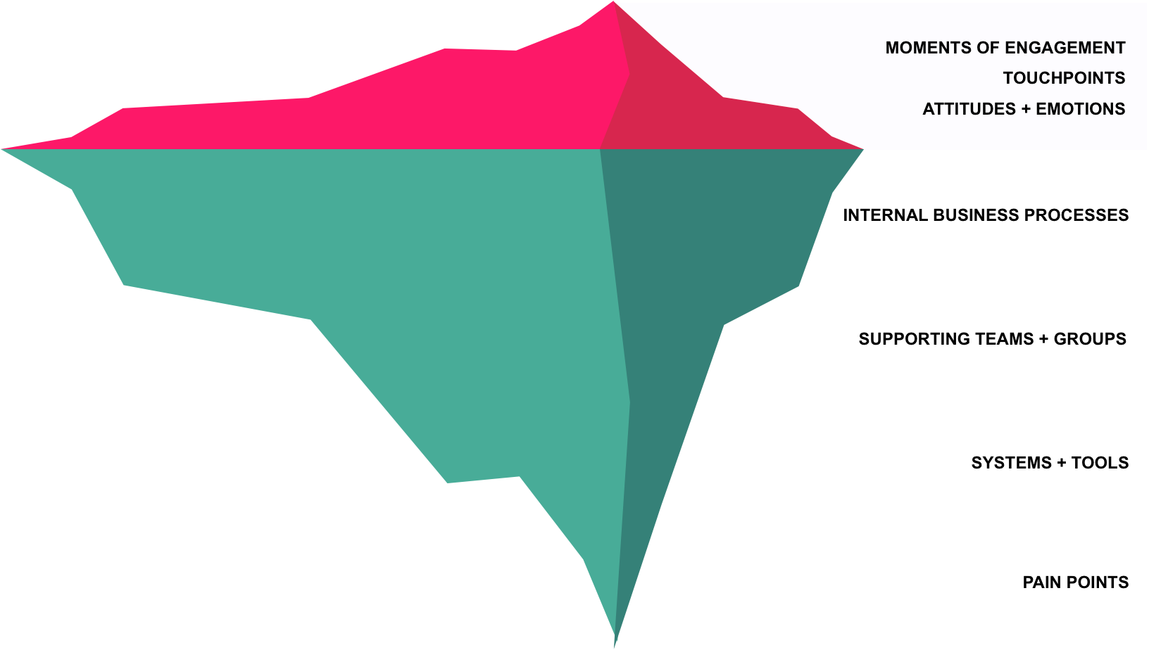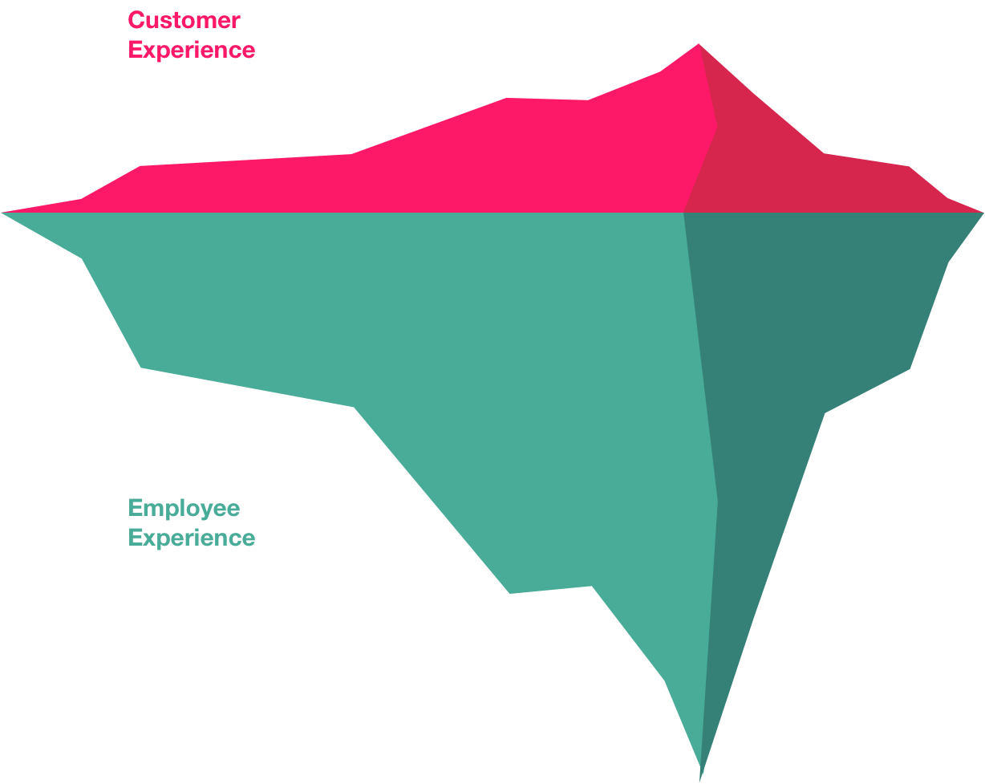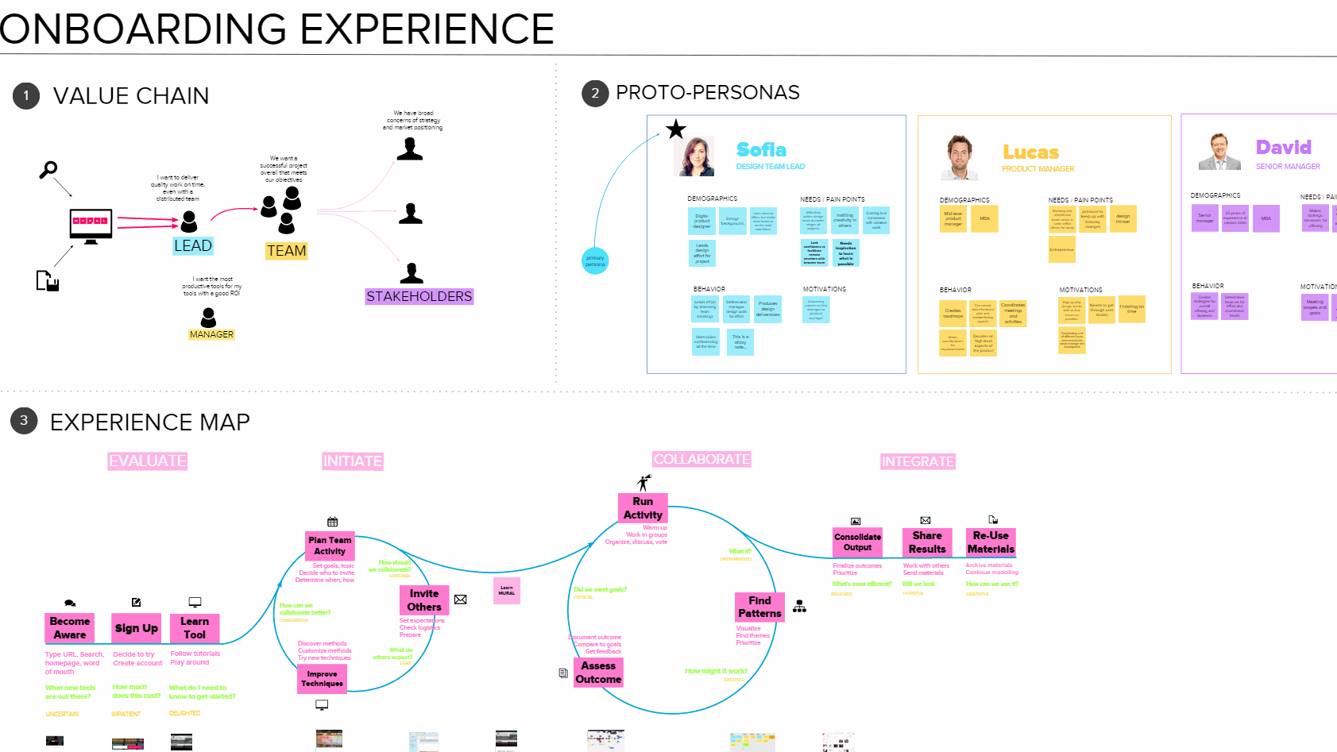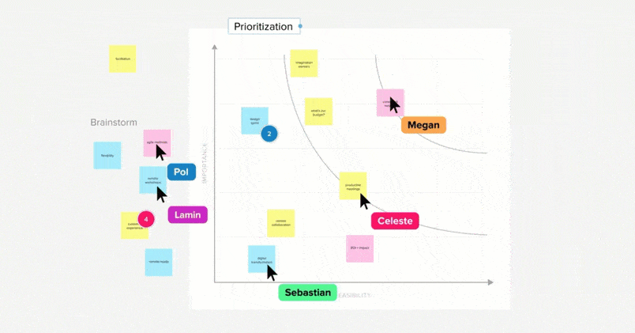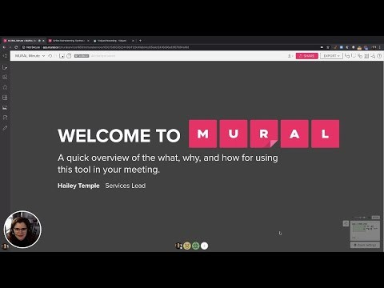

**PEOPLE**

2 - 10

**TIME**

4 - 8 hours

**DIFFICULTY**

Intermediate

Unite experiences to prioritize ideas and focus areas

**Customer & Employee Journey Map**

Customer & Employee Journey Map framework courtesy of our friend **Seema Jain** at MURAL

**Workshop date**

**01 20**

**Agenda**

**1**

**2**

**3**

**4**

Visualize the **Customer** and **Employee** interactions and touchpoints using Journey Mapping

Identify Moments of Truth by evaluating issues and opportunities

Prepare Needs Statements by framing Moments of Truth

Flag the most compelling areas of focus using Visualize the Vote

**Your facilitation team**

**Participants**

**Introduction**

**Customer Experience**

**Employee Experience**

**Resources:**

**Rapid Techniques for Mapping Experiences:**

**Facilitation Superpowers | MURAL**

**Webinar Recap**

**4 Steps to Creating Digital** from digital-first companies and

Insights, tools and case studies **Welcome to MURAL. Know**

**Customer & Employee Journey Maps**

Back to All Posts "Rapid

expert facilitators Our mission at **what, why, and how to use**

Techniques for Mapping

MURAL is to inspire, enhance, **MURAL before your**

Experiences," webinar by Jim and connect Imagination

**meeting.**

Back to All Posts I recently had Kalbach Understanding your Workers globally. We believe You are using MURAL as part of

the pleasure of presenting at the customer's experience is the

Experience Design 2020 first step in creating solutions happen anywhere, as long as a short overview of what, why,

that innovation, change, can a meeting or workshop. Here is

Conference in Denver, CO with that provide real value. The use great minds can be connected and how to use the tool before

Rebekah Baker of Salesforce. of visual representations --

This year's theme was focused diagrams of the experience -- on exploring the boundaries of

what experience really means Mural

and how to use design to make an impact. Journey maps are ...

and collaborate towards a ... your meeting. Learn more about MU...

Mural

Youtube

Mural

**Tips for the facilitator:**

If this is your first time facilitating a digital workshop in MURAL or you just need a refresher, here are a few tips and tricks to make you look like a pro:

📩 Invite contributors to the canvas and test access in advance of your online workshop.

⏲ Timebox activities and use the built-in timer to keep each activity on track.

🟨 Use different colored squares (pseudo post-it notes) for each lane in the Customer & Employee Journey Map.

📸 Take screenshots of touchpoints and interactions that will provide additional context into what the experience looks and feels like. Scale screenshots down to visually line up with the customer behavior.

⭐️ Add icons to visually illustrate attitudes and emotions, powered by the Noun Project.

🙋‍♀️ Leverage the voting feature to prioritize 'how might we...' questions by voting anonymously.

🗓 Spread the workshop out over time. Try scheduling multiple “power hours” with time in between to tie up loose ends and prepare for the next wave.

👋 To bring the group back together, summon everyone to where you are in the canvas. Rest assured knowing everyone's seeing what you're seeing.

**01**

**Name Organization Role**

**Name Organization Role**

**Name Organization Role**

**Name Organization Role**

**Name Organization Role**

**Name Organization Role**

**Name Organization Role**

**Name Organization Role**

**Name Organization Role**

**Name Organization Role**

EMPLOYEE EXPERIENCE

CUSTOMER EXPERIENCE

|  |  |  |  |  |  |
| --- | --- | --- | --- | --- | --- |
| Moment of Truth (CX) | Human Errors can cause | Less interactive display | Network issues may araise | Fritter of data | Misuse of patients data |
| Moment of Truth (EX) | Lack of Agility | Lack of detection of problems in real time. | Sometimes lackage of ideas may occur | Displacement of data causes several issues | Impacts relevant data |

|  |  |  |  |  |  |
| --- | --- | --- | --- | --- | --- |
| Moment of Truth (CX) | Make frustations due to delay | Lack of intractions with helpers | Customer can test the progress | Customer can test the hypotheses | Poor visual design |
| Moment of Truth (EX) | Sometimes data requires aptitude and technical knowledge | Efficiency is improved | Information data can be obscured | It can handle large amount of data | All data are stored in one place |

|  |  |  |  |  |  |
| --- | --- | --- | --- | --- | --- |
| Moment of Truth (CX) | Customer can get many details | Customer can make desicion to review information | Customer can increase Performance standard | Customer can save time while using dashboard | Customer can increase profts and productivity |
| Moment of Truth (EX) | Can tell the trends | Saving time by developing customer time | Developing dashboards can empower end users | Can create multiple reports into visuals | Can also change the complex data easy to and ready to interpret |